### Part m - Time Series Forecasting with Vertex AI and BigQuery ML

In this document, there are screenshots of -

* Transform data so that it can be used in an ML model
* Visualize and explore data
* Use BigQuery ML to create a time-series forecasting model
* Build a time-series forecasting model with TensorFlow using LSTM and CNN architectures

1. Creating notebook instance

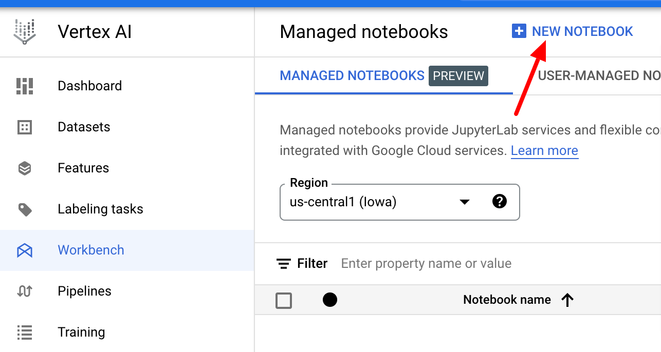

1. Creating a table for dataset on BigQuery

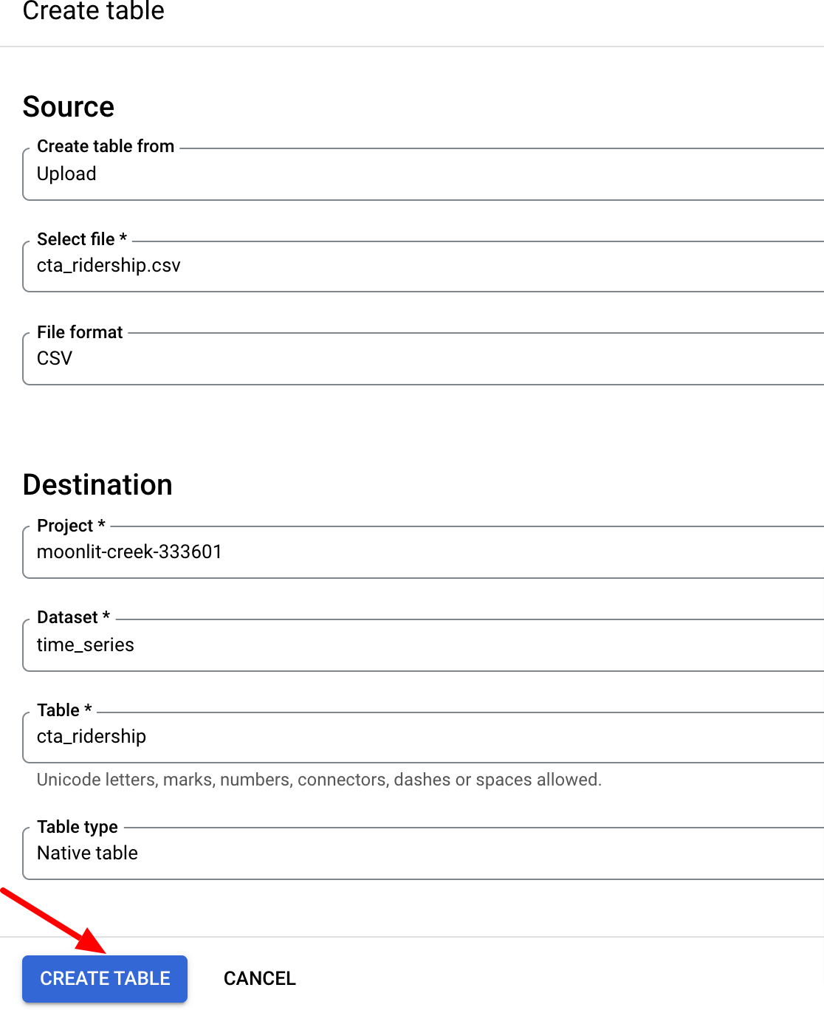

1. Creating a model using BigQuery

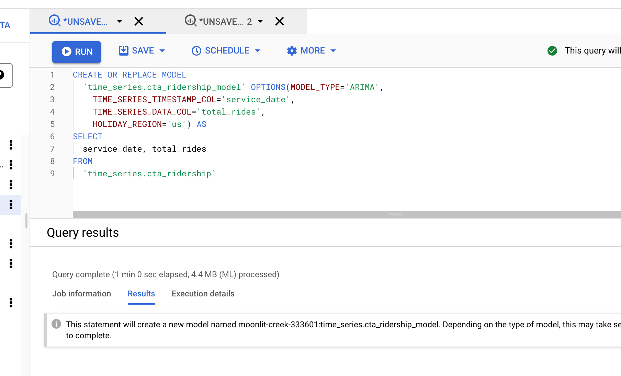

1. Model evaluation

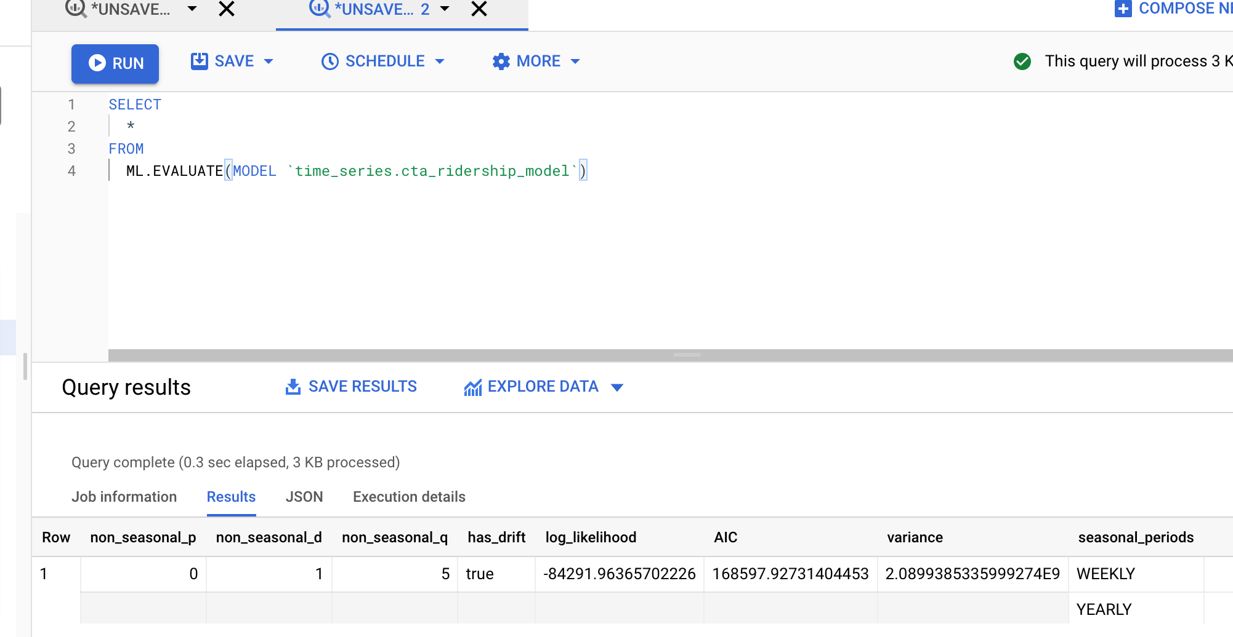

1. Forecasts using the model

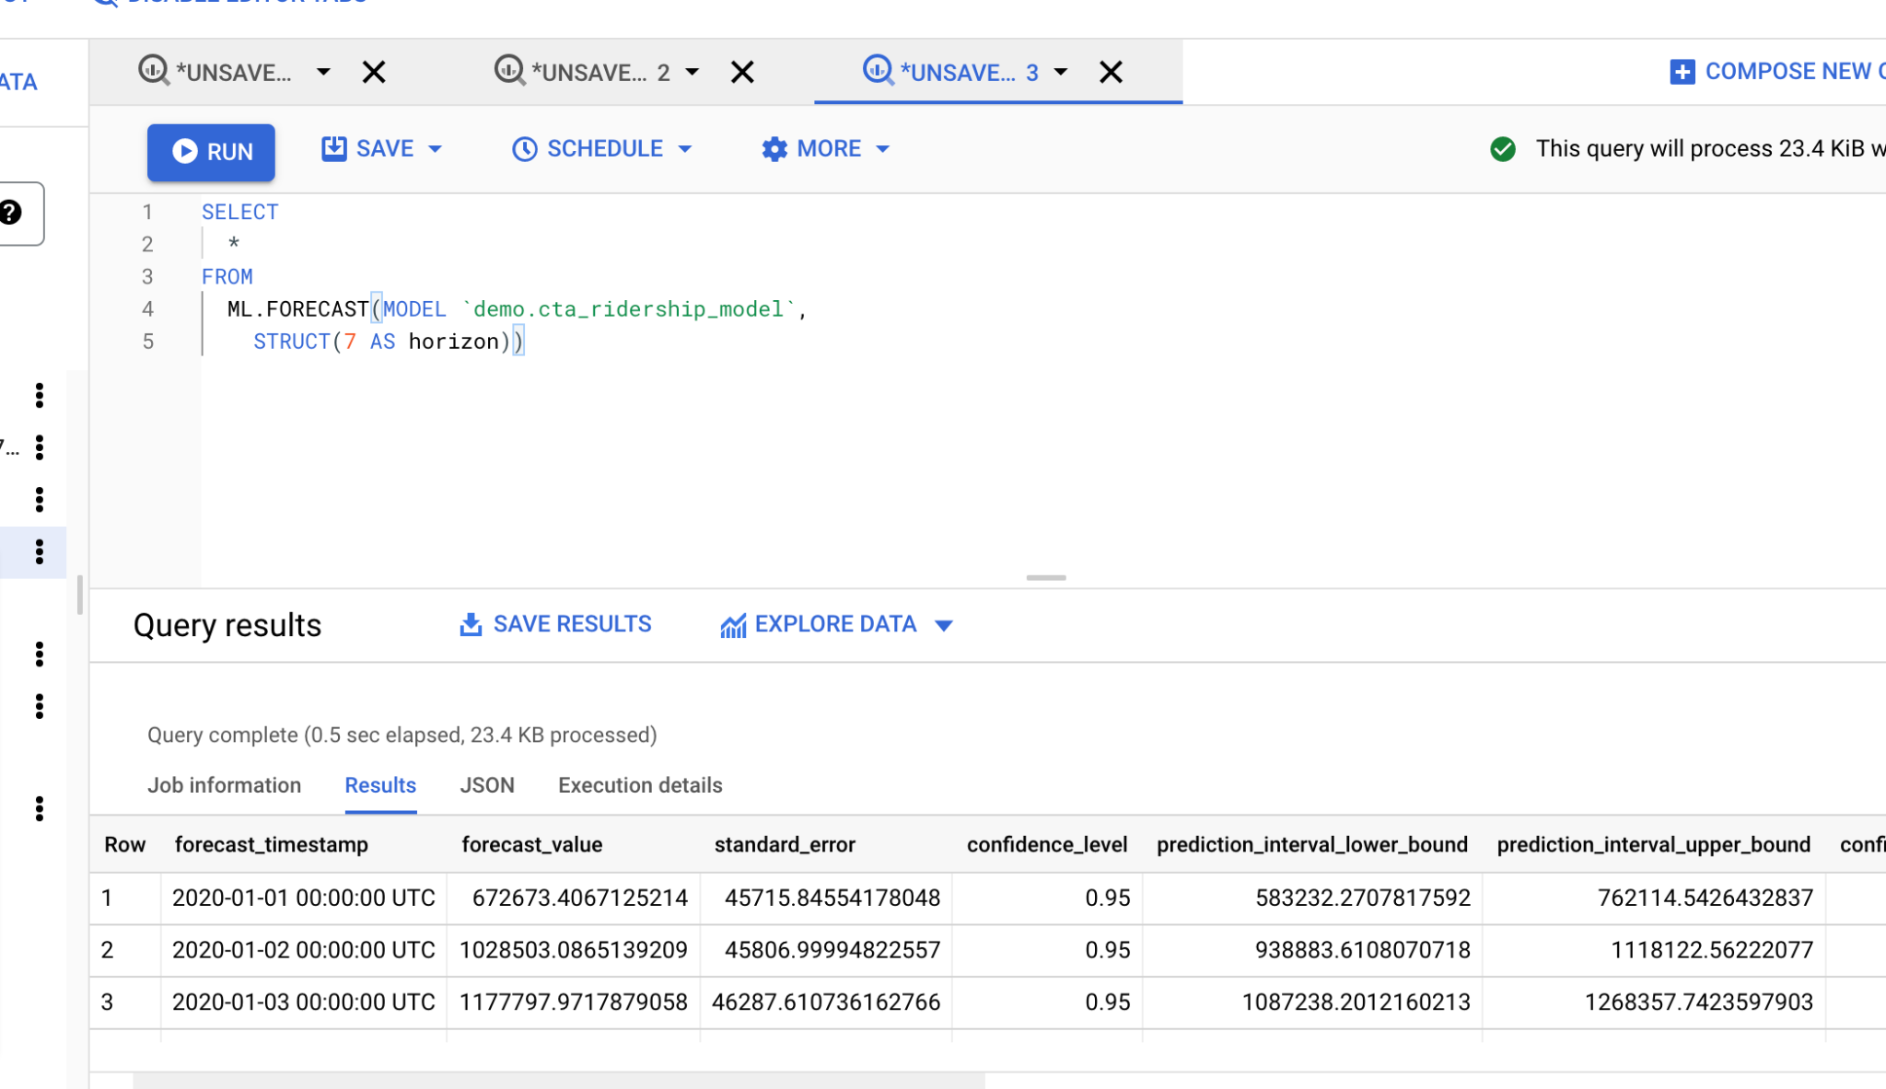

1. Training on vertex AI using data from the BigQuery



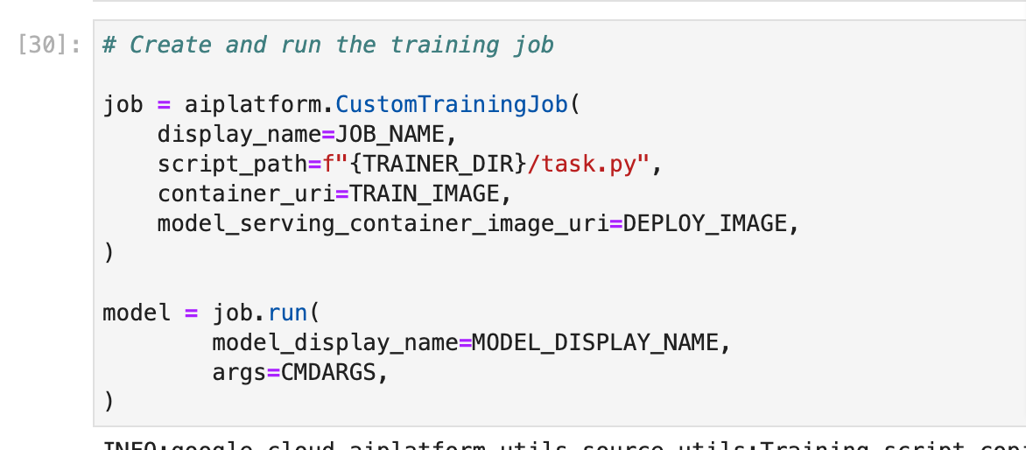

Deploying the model to an endpoint

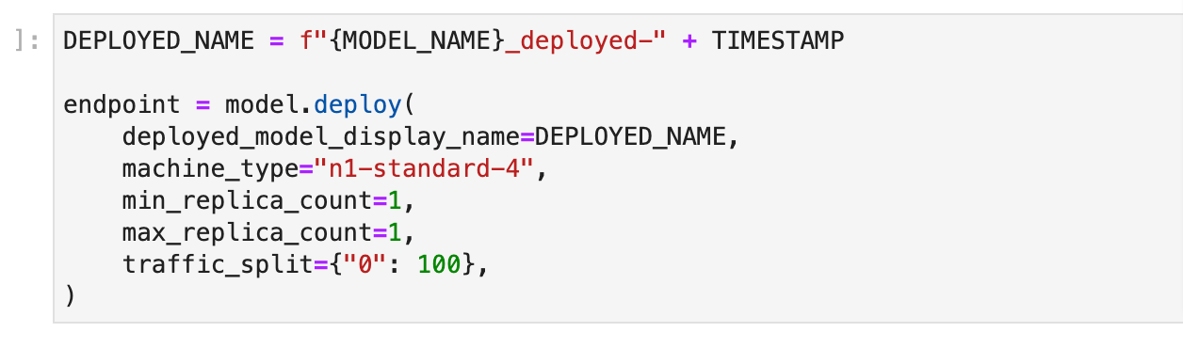

Predictions from the deployed model

